Relatório 3 Liec

1) a)
A | B | C | D
0 | 0 | 0 | 0 | 0
0 | 0 | 0 | 1 | 0
0 | 0 | 1 | 0 | 0
0 | 0 | 1 | 1 | 0
0 | 1 | 0 | 0 | 0
0 | 1 | 0 | 1 | 0
0 | 1 | 1 | 0 | 1
0 | 1 | 1 | 1 | 0
1 | 0 | 0 | 0 | 0
1 | 0 | 0 | 1 | 0
1 | 0 | 1 | 0 | 0
1 | 0 | 1 | 1 | 0
1 | 1 | 0 | 0 | 0
1 | 1 | 0 | 1 | 0
1 | 1 | 1 | 0 | 0
1 | 1 | 1 | 1 | 0

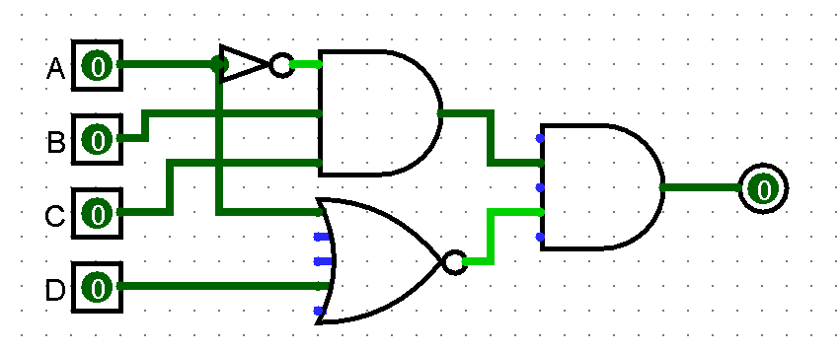

b)
A | B | C | D | E
0 | 0 | 0 | 0 | 0 | 0
0 | 0 | 0 | 0 | 1 | 1
0 | 0 | 0 | 1 | 0 | 0
0 | 0 | 0 | 1 | 1 | 1
0 | 0 | 1 | 0 | 0 | 0
0 | 0 | 1 | 0 | 1 | 1
0 | 0 | 1 | 1 | 0 | 0
0 | 0 | 1 | 1 | 1 | 1
0 | 1 | 0 | 0 | 0 | 0
0 | 1 | 0 | 0 | 1 | 1
0 | 1 | 0 | 1 | 0 | 0
0 | 1 | 0 | 1 | 1 | 1
0 | 1 | 1 | 0 | 0 | 0
0 | 1 | 1 | 0 | 1 | 0
0 | 1 | 1 | 1 | 0 | 0
0 | 1 | 1 | 1 | 1 | 1
1 | 0 | 0 | 0 | 0 | 0
1 | 0 | 0 | 0 | 1 | 1
1 | 0 | 0 | 1 | 0 | 0
1 | 0 | 0 | 1 | 1 | 1
1 | 0 | 1 | 0 | 0 | 0
1 | 0 | 1 | 0 | 1 | 0
1 | 0 | 1 | 1 | 0 | 0
1 | 0 | 1 | 1 | 1 | 1
1 | 1 | 0 | 0 | 0 | 0
1 | 1 | 0 | 0 | 1 | 1
1 | 1 | 0 | 1 | 0 | 0
1 | 1 | 0 | 1 | 1 | 1
1 | 1 | 1 | 0 | 0 | 0
1 | 1 | 1 | 0 | 1 | 0
1 | 1 | 1 | 1 | 0 | 0
1 | 1 | 1 | 1 | 1 | 1
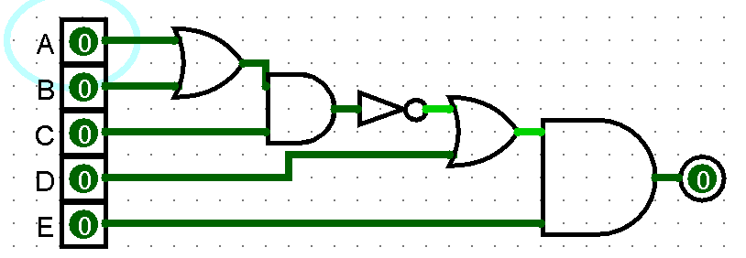

3)
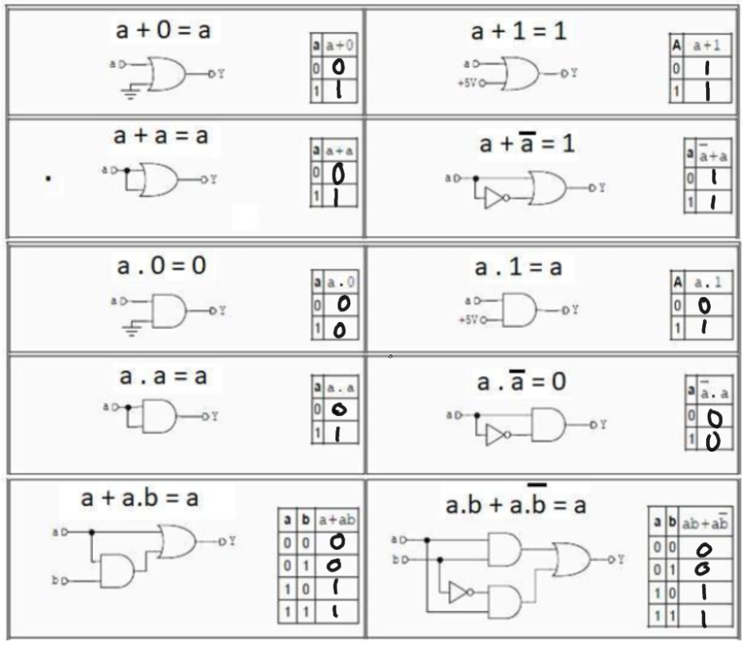
4)
Fogo | Energia | Gas | F + E . G
0 | 0 | 0 | 0
0 | 0 | 1 | 0
0 | 1 | 0 | 0
0 | 1 | 1 | 1
1 | 0 | 0 | 1
1 | 0 | 1 | 1
1 | 1 | 0 | 1
1 | 1 | 1 | 1
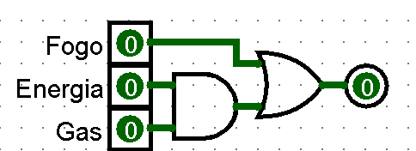

5)
A | B | C
0 | 0 | 0 | 0
0 | 0 | 1 | 0
0 | 1 | 0 | 0
0 | 1 | 1 | 1
1 | 0 | 0 | 0
1 | 0 | 1 | 1
1 | 1 | 0 | 1
1 | 1 | 1 | 1
